PROSPECTUS

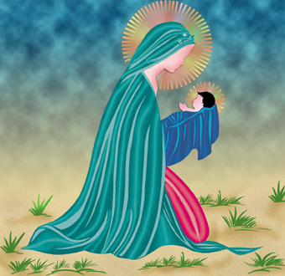

windows, MS – word , Ms – excel , Ms – powerpoint, visul, HTML, Internet
ELECTIVE - 1 : C Language, c++, OPPS
ELECTIVE - 2 : Tally ERP 9 / Prime
ELECTIVE - 3 : Corel Draw, Photoshop

Honour ‘s in Diploma Computer Application
Front End Back End
HTML 5 C, C++
CSS 3 SQL
Javascript Java python
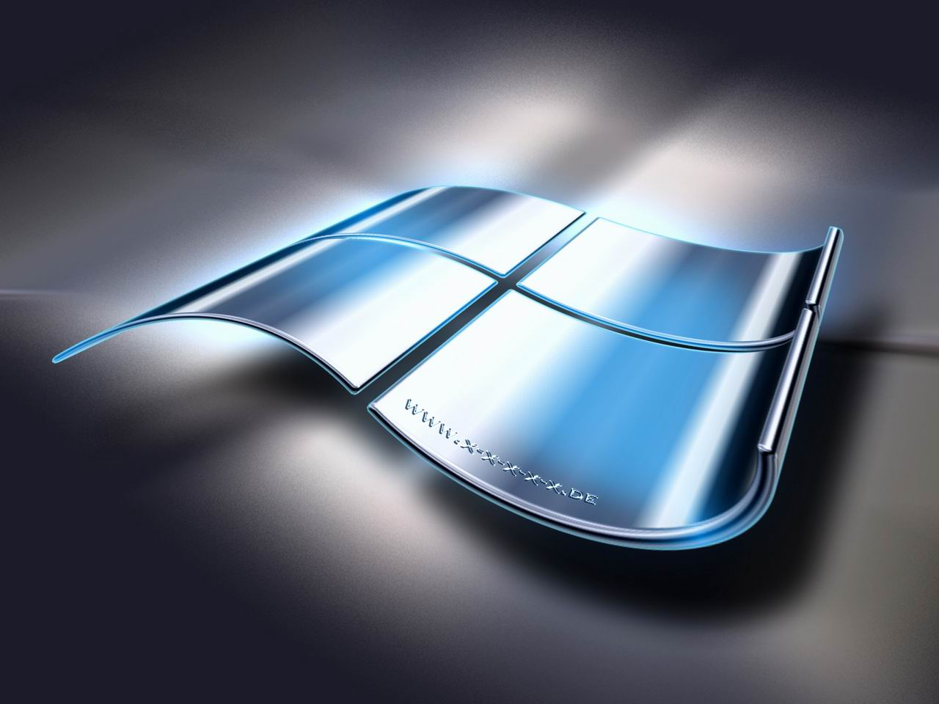
post graduate diploma in full stack development

post graduate diploma in full stack development

AN ISO 9001:2015 CERTIFIED INSTITUTION
computer software education
cse


PGDFSD -12 Months

HDCA – 6 Months

Honour ‘ s Diploma in Multimedia Programming
HDMP - 12 Months
Sem 1 : Print Media
corel draw , Photoshop, Indesign Illustrater
Sem 2 : 3D Animation / Web Designing
Flash, Swish, Fireworks, Dream weaver, HTML
Sem 3 : 3D Animation and Graphics
Sound Forage, 3D Studio Max, Cool 3D,
Premiere, After Effects


ADMP - 9 Months
Advanced Diploma in Multimedia Programming
MS windows , corel draw , photoshop,
Indesign, Illustrator, flash, fire works
Sound forge, premiere

cse



Diploma in Web Designing
DWD - 6 Months
software computer education

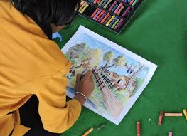
Windows, Corel Draw, Photoshop,
Flash, Dreamweaver, HTML,
Flash (Script)

PGDCA - 8 Months
Post Graduate Diploma in Computer Application

MS – Windows MS – Word, MS – Excel,
MS – Powerpoint, C Programming
Visual Basic, HTML, Java – Basic
C ++, SQL


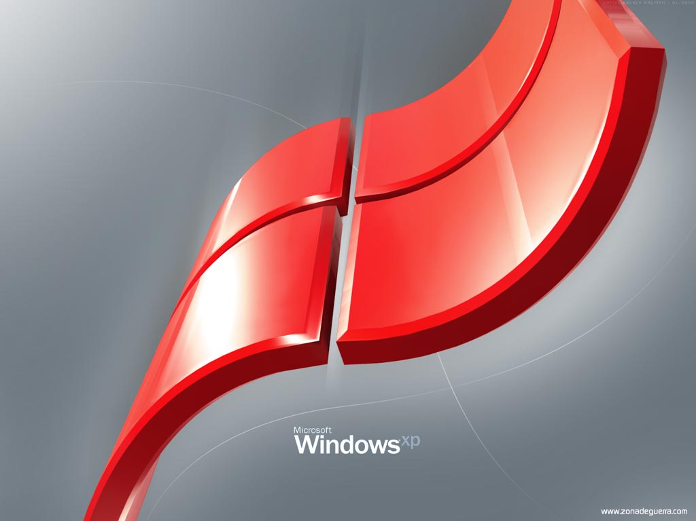
C Language, OOPS Using C++,
HTML, JAVA, RMI,
Servlet, Project
ADJP – 4 Months
Advanced Diploma in Java Programming
MS – Windows,
C Programming, C ++,
PYTHON

DPP - 3 Months
Diploma in PYTHON Programming

MS – Windows, MS-Word,
MS – Excel, C Programming,
C ++, MS - PowerPoint
DCA - 4 Months
Diploma in Computer Application

cse
AN ISO 9001 : 2015
CERTIFIED INSTITUTION


COMPUTER SOFTWARE EDUCATION
DOAC - 3 Months
AUTO CAD

